EXP 7 : PERFORMANCE EVALUATION OF AM GENERATION AND DETECTION UNDER NOISY CHANNEL CONDITIONS USING MATLAB

SOFTWARE USED : MATLAB SOFTWARE

CODE :
clc; clear; close all

Fs=1e5; t=0:1/Fs:5e-3;
fm=1e3; fc=10e3; mu=0.7;
m=cos(2*pi*fm*t);

AM=(1+mu*m).*cos(2*pi*fc*t); % AM generation
SNR=10; % SNR in dB
rx=awgn(AM,SNR,'measured'); % Noisy channel

env=abs(hilbert(rx)); % AM detection
d=(env-mean(env))/mu;
m=m-mean(m);

subplot(4,1,1),plot(t,m),title('Message Signal'),grid on
subplot(4,1,2),plot(t,AM),title('AM Signal'),grid on
subplot(4,1,3),plot(t,rx),title('AM Signal with Noise'),grid on
subplot(4,1,4),plot(t,d),title('Detected Signal'),grid on

fprintf('SNR = %d dB\n',SNR);
fprintf('MSE = %.4f\n',mean((m-d).^2));
MODEL GRAPH :
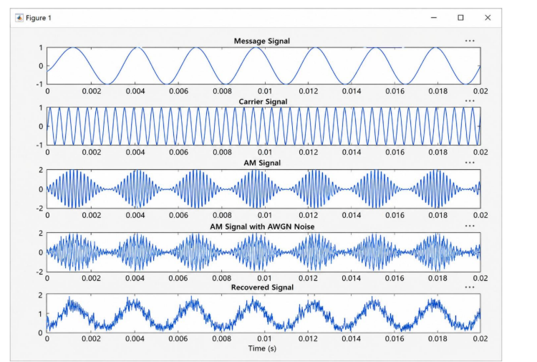

RESULT :
